

**ME 492/ECE491 – Senior Design**

**Group 2 - winter 2014**

**Final Design Report**

**Project Title: Industrial Parts Counter**

**Professor: Dr. Latcha, Dr. Gu**

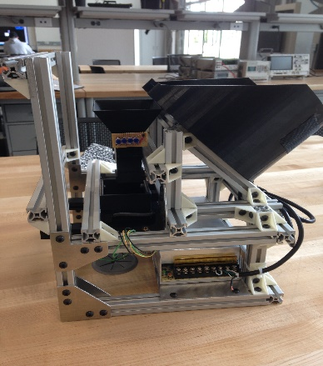

**Team Members**: Paul Kruchko (EE)

Michael Laba (ME)

Bryan Jagielo (EE/CE)

Xiaoang Tong (EE)

Monika Shaeff (CE)

Ran Ao (ME)

Xinfeng Shi (ME)

**Table of Contents:**

1. **Introduction**…......................................................................................................................1
2. **Design Specifications**...........................................................................................................2
3. **Design Overview**…..............................................................................................................3
4. **Mechanical Subsystem**…....................................................................................................4
5. **Electrical/Electronic Subsystem**…….................................................................................5
6. **Computer/Software Subsystem** ……................................................................................6
7. **Discussion**……....................................................................................................................7
   1. **Technical Discussion**…………………………………………………………………8
   2. **Professional and Societal Context**………………………………………….…….….9
      1. **Engineering Standards**……………………………………………….……..…..10
      2. **Safety**………………………………………………………………….….………11
      3. **Economic factors**……………………………………………………………...…12
      4. **Reliability**……………………………………………………………………...…13
      5. **Aesthetics**…………………………………………………………………………14
      6. **Potential customers**………………………………………………...……………15
      7. **Societal impact**…………………………………………………………...………16
   3. **Information Literacy**………………………………………………………...………17
8. **Conclusions and Recommendations**……………………………………………………18
9. **References**…………………………………………………………………………..……19
10. **Appendices**……………………………………………………………………….………20

**Introduction:**

1. Description of the project challenge

The challenge of the project was to produce a machine that could be used on an assembly line. The machine would be useful by helping workers counting out small fasteners or parts to be assembled as the main assembly passes by on the line. The machine would be able to provide the correct number of parts each time the line worker request it. This would eliminate workers counting by hand and either coming up short on their count or taking too many parts. Extra parts tend to be discarded on the floor which is both a waste of materials and a safety hazard.

1. Brief description of the design solution to the project challenge

The solution that we have come up with is a case feeder design that uses a bowl to hold the main part population. Inside the bowl a disk with cut-outs will take each part one at a time to the top of the bowl and dispense it down a funnel. The funnel is lined with sensors that will count the parts as they fall into the presentation bin. The presentation bin holds the parts until the count goal is achieved. From here the operator pushes on the slider just under the bin. This allows the parts to drop into the operator’s hand. This is how we intend to distribute our parts.

**Design Specifications:**

The system that Group 2 proposes is a closed-loop, feed-back, electronically controlled rotating part feeder that agitates, actuates, and organizes a set of homogenous hardware components that are to be counted and dispensed into the awaiting hands of the operator/user. There are basically four subsystems in the mechanical design: screening subsystem, transportation and detecting subsystem, dispensing subsystem, and supporting frame subsystem.

Basically, the hopper bowl, the disk, the inserts make up the whole screening subsystem. They are all printed by 3D printer to ensure high accuracy of the size. Instead of printing six different disks, different kinds of disk inserts are used to save materials. And also the bowl inserts are used to fit different parts. The hopper bowl was designed according to the total volume of the largest parts to make sure it’s big enough to hold any six kinds of materials. The diameter of the bowl was decided by the diameter of the plate (200mm), which is decided by the length of the materials. All the materials will be put into this gradient hopper bowl, and the plate at the bottom of the bowl will begin to rotate driven by the motor, and also the agitators will begin to stir the parts. The parts inside the bowl will fall into inserts under the influence of gravity and the agitation. When the single part is rotated onto the higher side of the plate, all the parts will drop through the gap one by one, and here the simulation of the parts are completed.

For the transportation subsystem, there is a funnel with sensor inside it. The parts will drop into a funnel one by one, and the eight pairs of IR sensor on two levels can count the part that goes through. When it count to the quantity the user needed, the feedback control will apply to stop the motor. The upper size of the funnel is bigger than the lower size to avoid getting stuck, and also the slop is smooth enough. According to the parts quantity the user need, there will be a motor speed control to speed up the rotation or slow it down. This control will make sure we can transport enough parts in a certain time. After careful examination of the system’s static and dynamic characteristics it was determined that a motor with a minimum torque output of 20oz.-in. would be sufficient. Given that the there is considerable torque loss in the shaft of any given motor (~10%) and the need to both observe and control the speed of the motor it was determined that the 131:1 gear motor offered by Pololu was a desirable material solution for the motoring needs of the system. This motor offers 250 in-oz. of torque at 80 rpm, giving a safety factor of 12.5 and an encoder resolution of 64 counts per revolution, creating enough sample for an adequate velocity measurement. Control can be performed by implementing a PID controller in software on the microcontroller to control velocity output for desired velocity state or an integrated motor controller can be purchased that controls the motor with only a simple command from the microcontroller controlling the rest of the system. Given allocated memory and system response time it might be desired to control the motor using a motor controller.

For the dispensing subsystem, there is a push slider and a presentation. After we get the right number of parts, the motor will stop rotating and the certain parts will be inside of the dispenser. Two springs with proper spring constant are on the dispenser, which can make it go back to the original position after the user push and get the parts.

For the supporting frame subsystem, the frames are utilized to hold up all the mechanical and electronic components. The cross section of the frame is 20mm×20mm, and the material is aluminum alloy to ensure that it’s strong enough to make the whole setup steady. The frames are fixed together by the joints, which are printed by 3D printer.

**Design overview**

In order to discribe the overview of the mechancical system. We first looked at existing machines in industry and broke down what made them successful.

After examining a few machines we came to up with the following flow chart which each part followed in order to be acuratly organized, counted and moved from a major parts group. We would encorporate the same ideas into our design in order to make it successful

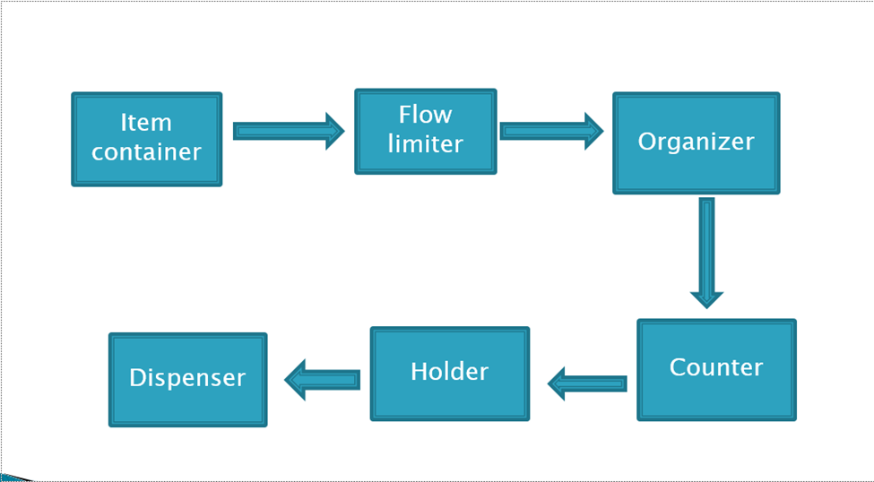

As seen in the above flowchart, the main population had to be first contained. Then the machine had to have some way of initiating the parts to move. Most machines used motors or agitators to create a mass flow from the major population of parts in the machine. The parts then are organized by geometry and orientation from the main material flow. Any part that did not match the orientation or the requested geometric restraints, was rejected back to the major population. This allows for a controlled flow of parts to feed one at a time into the counter. As parts move past the counter, the machine keeps track of how many are going to be dispensed, what the count is and how many parts are left in the bowl. The parts then move to a holder. In the holder, orientation may or may not matter depending on if orientation needs to be held for later processes. In our case we did not need to hold any particular orientation as long as all the parts where contained in the holder. The holders’ main job is to hold the current count of parts to be dispensed. This is to ensure that the operator is to get all the parts at once out of the dispenser, instead of parts coming out one at a time. The final piece is the dispenser itself. Each machine needed a way of presenting or releasing the held parts to the operator.

We needed to control aspects of the mechanical side, so we made a second chart that would work with the mechanical flow to ensure control to the machine.

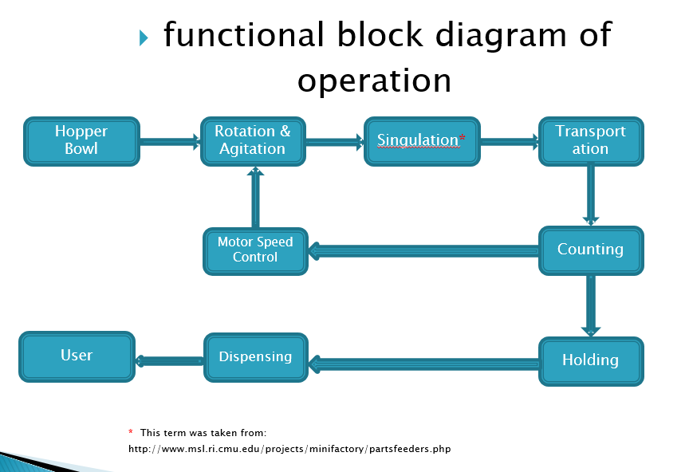

Each section in the diagram above was a strategy used in controlling the number of parts and part flow within the machine. The microcontroller would have feedback from sensors in the funnel and dispensing bin to control the motor speed and ultimately the part flow within the machine. This would mean that we could control the on time delivery of each count, know how many parts have been dispensed, how many parts are in the machine, and most importantly, how many parts are in the count. The microcontroller would have the ability to do the following: allow for user to select part type, count, control motor speed, keep track of parts in the machine, alert the operator when the parts are ready to dispense and start the count again after the operator retrieves the parts.

**Mechanical Subsystem:**

The mechanical subsystem is all pieces or parts of the machine that provide support or function to the machine. Each part of the machine had to be selected or made with both function and the ability to be assembled in mind.

**Final Design Calculations:**

Considering that we should have some gaps between that “Gaps” for our parts, we need make the diameter bigger. Also, we have 50 parts, and we need enough volume for these 50 parts.

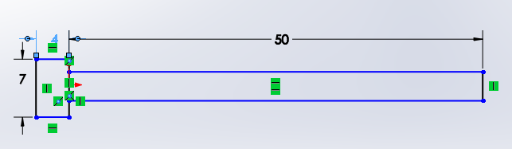

(50mm screw)

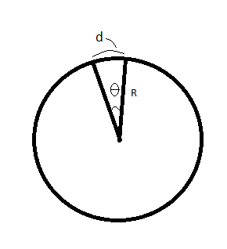If we set 6 gaps in a plane, and we see each gap occupy θ angle. Then d= θ, R≈54mm   
(θ<60°)

1) Set θ=5°=0.0873rad, we find R=618.8mm

2) Set θ=15°=0.262rad, we find R=206.3mm

3) Set θ=30°=0.52rad, we find R=103.13mm

4) Set θ=40°=0.698rad, we find R=77.3mm

5) Set θ=50°=0.87rad, we find R=61.9mm

Thus, we can set the diameter of the circle as about 206.3mm, which is the third option. We chose 200mm for the diameter of the planes. Then every part can work for this circle. All we need is changing the plane for different part.

**Some Calculation about the Torque**

1, for the 10*25mm Socket Head Cap Screw (Heaviest one)

$M_{total}=1.36kg$ $G=13.328 N$ The angle was set as 45 degree

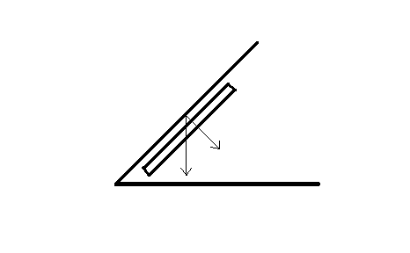So the support force of the plate: $N=G*Sin45=9.424 N$

The friction between the parts and the plate: $f=µ*N=1.4136N$

(All the calculation above ignored the gaps area, and also ignore the friction between the parts and the bowl bottom, because their friction should be cancelled out.)

The Torque that needed: $T=F*r$

It’s hard to decide the radius r, we just set the r biggest, which is r = m

So the torque we need: $T=F*r=1.4136*0.1m=0.14136N*m$

Then the power should be: $P=T*n*η/9549$ ($η=0.8$)

As long as the n is decided (which is r/min) the power P can be calculated.

**The range of the moment of inertia of Plates:**

For the 54mm Screw: $I=0.2803g*m^2$

For the 35mm Screw: $I=0.3163g*m^2$

For the 4mm Nuts: $I=0.2459g*m^2$

For the 10mm Nuts: $I=0.3542g*m^2$

For the Anchor: $I=0.3393g*m^2$

For the anchor srew: $I=0.3633g*m^2$

So basically the range of the moment of inertia of plates are:

I: $0.2459g*m^2$ ~ 0.3633g*m^2

**The range of the moment of inertia of Plates:**

Assume all the 50 parts as a point, and at the edge of the plates:

For the 54mm Screw: $I=3g*m^2$

For the 35mm Screw: $I=13.6g*m^2$

For the 4mm Nuts: $I=0.326g*m^2$

For the 10mm Nuts: $I=4.665g*m^2$

For the Anchor: $I=0.93g*m^2$

For the anchor screw: $I=11g*m^2$

So the range of the moment of inertia of both plates and parts are:

I: $0.57g*m^2$ ~ 13.92g*m^2

But the actually “I” should be smaller than what from the calculation.

**For the spring constant of the springs that use on the presentation bin:**

For the heaviest parts which are 10×25mm Socket Head Cap Screw, each one:

$$m_{ea}=27.2g$$

And consider that the user need six parts of that, so

$m_{6}=163.2g$ And $m_{silder}=249.66g$

So, $m_{total}=412.86g$

Set the friction coefficient $µ=0.15$, which is the “most forces needed” situation.

And the friction f between the sliders:

$$f_{max}=N×µ=G×µ=0.6075N$$

Some preload (less than 5mm) should be applied. The inner distance is 65mm, and the outer surface is 70mm. The original length should be a little smaller than 65mm, could be 60mm, and then we have about 5mm preload. So the total extension should be 80mm:

$$F=-k×x$$

To make the 5mm preload distance work: $F_{5mm}>f_{max}=0.6075N$

$$F_{5mm}=0.005k×2>0.6075N→k>60.75N/m$$

And also, the spring constant shouldn’t be too big. The force that user need to apply on the slider shouldn’t be bigger than 30N. So:

$$k_{max}=\frac{{30N}/2}{0.08m}=187.5N/m$$

So, the spring constant range should be:

$$60.75N/m<k<187.5N/m$$

**Progression of Major Changes:**

Our first Idea came from industry as a vibration bowl. The idea was that the bowl would be agitated and actuated such that parts would pushed by friction and solenoid, around the bowl and up a spiral ramp. While moving to the top of the bowl, we could use limiters to orient the parts as they formed a single file line. We quickly realized that the amount of calculations to achieve the forces needed to vibrate the parts would be very difficult. . We removed this idea because it required more parts than necessary, and it was big and bulky. The dimensions on the outer frame where 540mm X 400mm X 350mm.

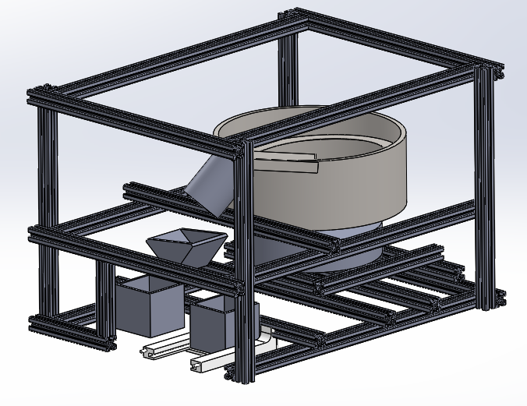What was also discarded from this idea was to have the option of a rejection bin for bad part counts. From figure __, it is illustrated that the parts would fall into a staging cup. If the count was wrong it was to dump the cup with a servo to the bin on the left. If the count is correct then the bin would dispense to the right, where the operator could retrieve the parts. This failsafe was removed because we felt that we could get an accurate count consistently enough to that it would be less than useful.

After more research, we considered two more Ideas. One used conveyor belts and limiters for part flow and the other used a set of rotating disks with slots to pick up parts one at a time and dispense them at the top of the bowl. These ideas where found from YouTube. The conveyor design used two belts and a limiters to organize and count parts. The case feeder used a disk with part slots to isolate and orient shell casings as they are moved one at a time to the top of a 45 degree slope. We chose the case feeder design with the bowl and disk, due to it being less complex, having components that could be easily calculated and we that the fabrication would not be too difficult. The concept was also more compact than the vibration bowl and the conveyor belt designs. We also liked how gravity was used to remove any extra parts caught by the machine. Figure __ shows a model of our chosen design concept.

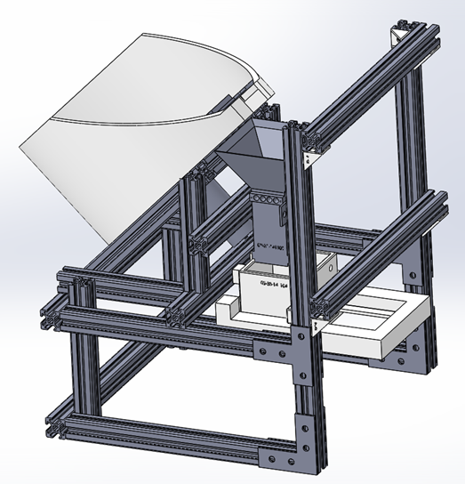

To hold the main population of parts on the disk and agitator, we knew our bowl had to have a volume that would hold the largest part volume but not completely fill the bowl. We also knew that the bowl would have to be able to move the longest screw. These dimensions influenced both our bowl size and slot dimensions at the top of the bowl and on the disks.

Originally we had hoped that we could print the bowl as one piece and the first bowl contained more ABS than what was necessary. A 3-D printer was expected to be used to make the bowl to ensure precision and because the printer would be able to fabricate our shape and eliminate extra fabrication processes with some other materials. The only thing the printer needs is material which is where the cost for making the parts is incurred. We first tried to eliminate some of the ABS material from the bowl by making the motor hole in the bowl wider. This changed or original plan to mount the motor directly to the bowl which would have made centering the motor shaft and assembly easier. We still had a high ABS volume for the bowl, in order to reduce the volume.

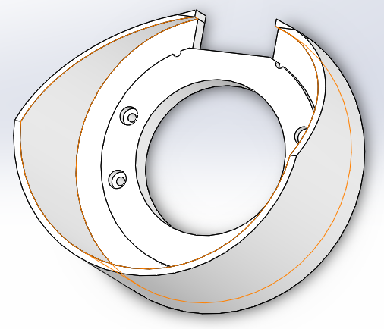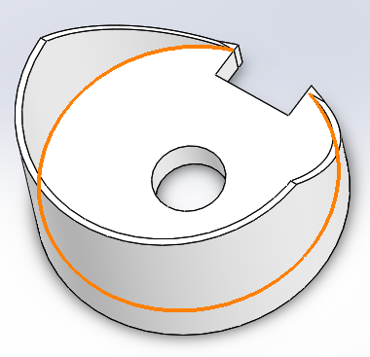

Additionally on the newer bowl a bolt pattern was included in the design to provide a mounting point for our bowl. We researched fasteners that would work for our design. By having the counter bore, the bowl can be fastened and the head of the fastener would be out of the way of any moving parts. Diameter for the threaded part of the bolt is 6mm to match the channel width on the 80/20 extrude. The counter bore itself is 13mm in diameter and 6.5 mm deep to contain the head of the bolt chosen.

During the mechanical process, we have utilized 3D printer for printing some of the major components of the machine. The material of these components is ABS, and the friction factor between ABS is 0.1. The tolerance of the printer is 0.2mm, so we need to consider the tolerance when designing the size of the components. In order to account for this tolerance, we fist made each part with perfect fit measurements. We could then build the CAD structure perfectly. When we needed make the part, the part model was then reduced by the printer’s tolerance at the interfacing edges of part. The part would be sent as a STL file to the printer, where it would be created. Most of our printed parts where 100% filled. This helped to improve the strength of the part due to no gaps existing within the part to cause internal stress concentrations.

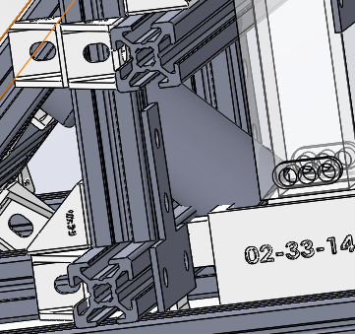When considering motor design and comparing that design to our model, we found that the motor packaging was interfering with the frame, bin and funnel designs. We had to reposition the motor to ensure that the motor was not going to contact any other components and cause a problem. To do this we mounted the motor by making a mounting plate that would hold the motor in place from the threaded holes on the gearbox. The plate could then be mounted to the 80/20 extrude just underneath the bowl. We found that doing this allowed for tight motor packaging and good positioning under the bowl. To take care of the rest of the position issue we extended the vertical member of the slope and relocated the horizontal mounting position. This kept our bowl angle at 45 degrees pulled the motor away from the funnel and other components.

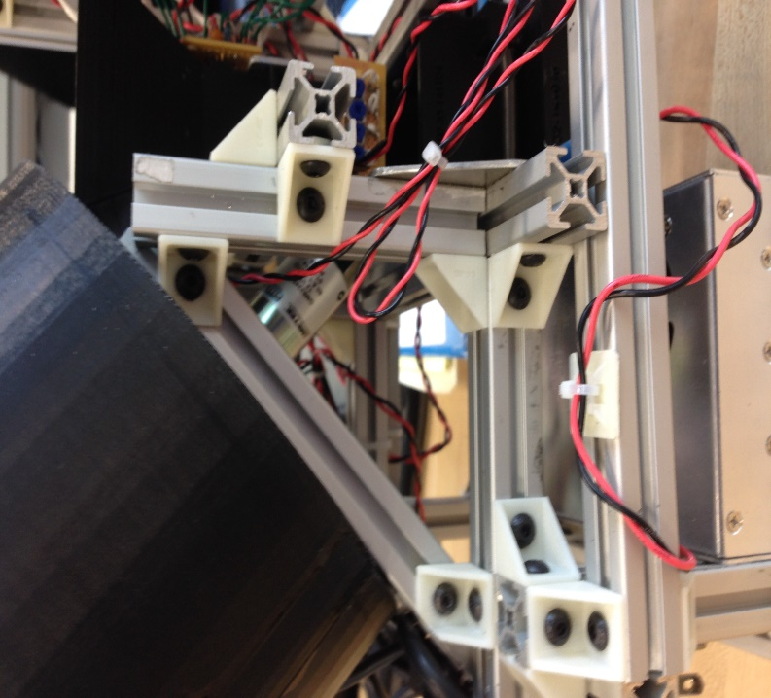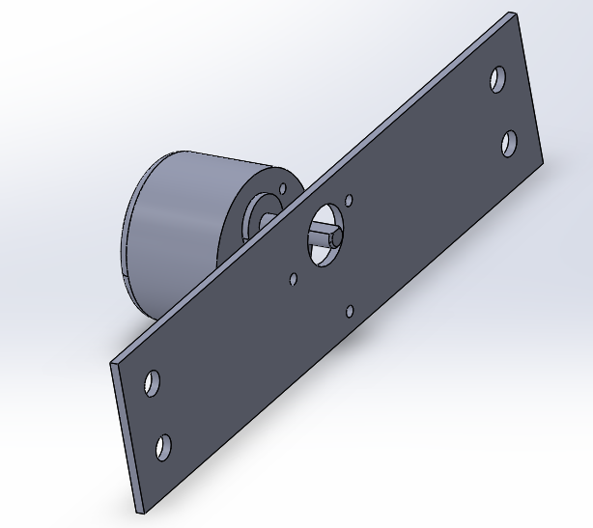

Our next change was to the presentation bin and slider. Pegs where added to the front face of the bin and back face of the slider to allow an anchoring point for our springs. We drilled a hole through the center of the pegs to push some of the spring wire through and wrap it. This creates a good anchor that displays the springs in a more professional manor. We also created location pegs for the front of the slider. In order to make the assembly work, the bin had to be riding along inner rails of the slider. To do this, an end needed to be open for assembly purposes. Once these parts where installed together, an end piece to the slider was fitted on the end pegs and glued into place. This ensured that the operator would have something to push on and it prevented the assembly from coming apart.

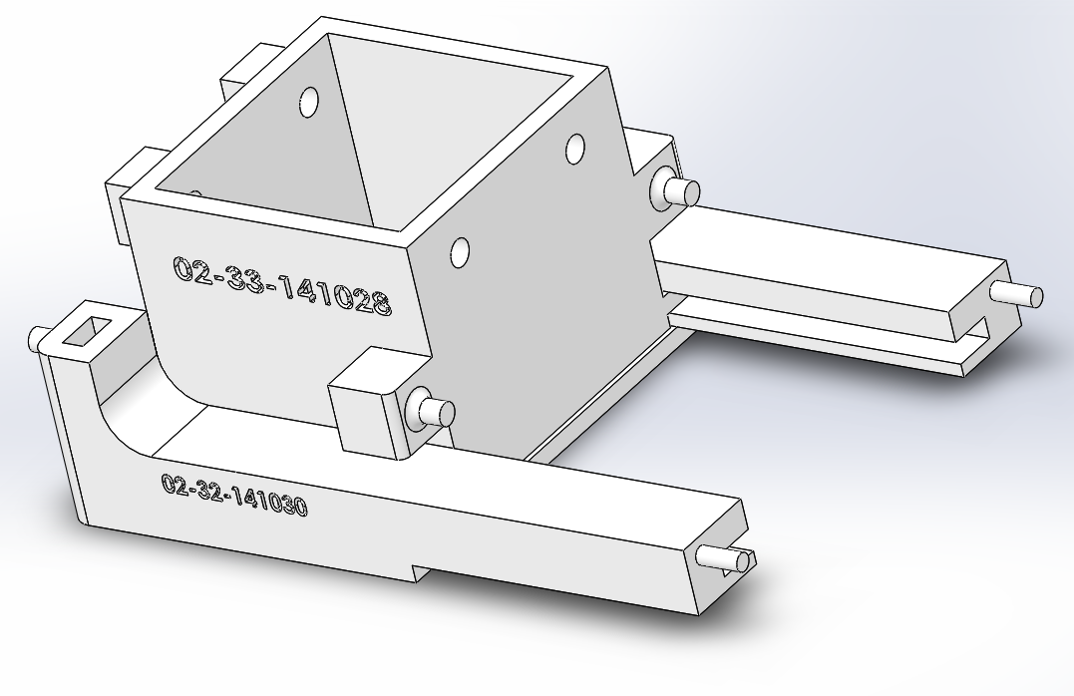

Back offsets on the bin where placed due to potential motor fitting issues. The offset also places the bin a little closer to the operator and provides more clearance between the operators hand and the power supply located in the lower rear part of the machine. The holes in the front where added to provide another mounting point to the frame. This additional mounting point was needed to distribute the force from the falling fasteners and greatly reduce moment created by the operator pushing on the slider. This reinforced the bin so that it would not brake under normal operation.

Due to considering the costs of making 6 different plates. We tried to print off a thin master disk design. The Master disk would have inserts that were to lock into the plate and have cut out slots that would only allow for one fastener to sit in the slot at a time. To prevent the insert from falling out, we used a puzzle feature and an edge made into the master disk to prevent the insert from coming out.

After printing the master disk and some inserts we started experimenting with the machine. Due to centripetal force, the inserts wanted to lift off of the disk. Parts would also fall down the face of the disk and cause the insert to pop out due to vibration. This lead us to look for a counter measure to the inserts popping out. We also discovered in the process that some of our insert slot designs where too large. This allowed for conditions where two parts could be moved up the incline drop into the bin at the same time with one slot. This was unacceptable because the intended function of each insert slot was to grab and isolate one part at a time.

The original reason for a single disk design with inserts was to keep the printing cost low. However, after printing some parts through our group leader’s work, a company called 3-M, we could print each of our disks for a low price of $2.50. This is a huge improvement over the professor Latcha’s printer, where we estimated that individual disks had a cost range of $20-$45. With this in mind, it made more sense to apply updated slot designs to individual full disks. We would solve both problems at once; the slot designs would be reprinted and optimized, and there would be no more inserts to pop out. Everything would be strong, have the same bonded material, and the wheel surface about each slot location is uniform.

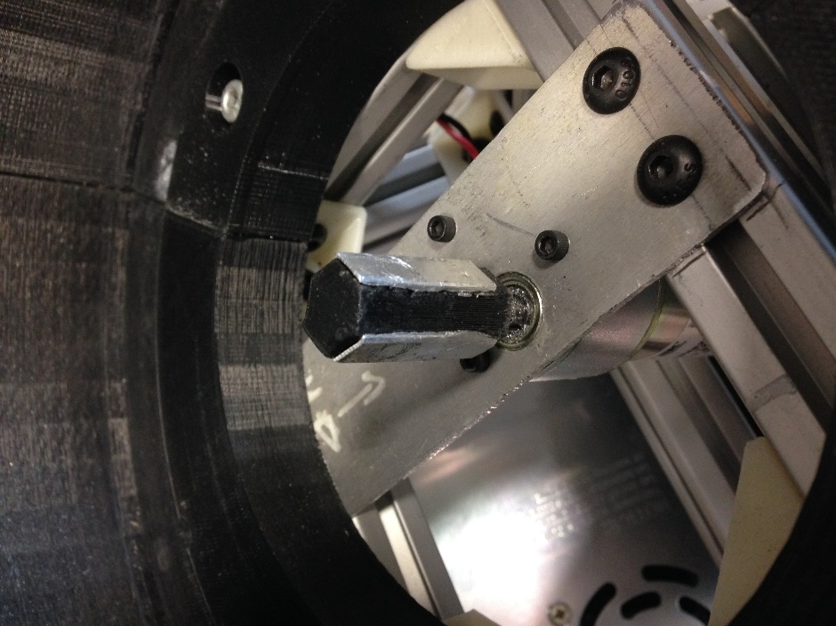 After some testing, it was noted that the shaft used for turning the disks was experiencing too much wear. We had assembled and super glued the shaft key piece to the original motor shaft. To fix this issue, we took 1mm thick sheet aluminum and cut it into 3, 7x25mm pieces to apply it to 3 faces of our hexagonal motor shaft. After super gluing these strengthening pieces into place, the disks would not fit on the shaft anymore due to the new pieces. To adjust the disks, an exacto-knife was used to carve out parts of the disk to fit it onto the key piece. Our addition prevented further wear on the shaft piece and prevented us from stripping out the key or the disk centers.

Our last experimental modification was the addition of an agitator that was placed and superglued in at the edge of the 10mm nuts, 4mm nuts, 50mm cap head screws, and drywall screws. This additional isolator was to grab and mix the nuts in the bowl such that they would be oriented with their face on the disk, making them easier to drop into the disk slots. During testing with the nuts, it was observed that the last nuts would land and orient themselves on the back wall of the bowl. The nuts would then slide and spin as the disk rotated underneath them. They would avoid the correct orientation to be picked up by the slots. To fix this the new agitator was applied with the flat side in the direction of rotation to grab and prevent “nut run”. This agitator would carry a few nuts towards the top and dump them so they would be in the correct orientation.

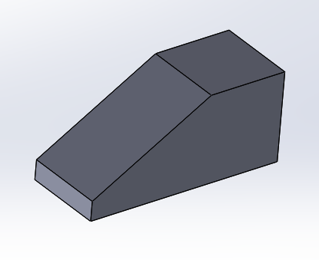For the bolts and screws, it was observed that more agitation was needed to allow for the disk to pick up the parts. Due to the geometry of the screws, parts often landed in an incorrect orientation for the slot. With only a flat disk, the mass of parts would slide over the plate with little agitation to properly orient the screws. The additional agitator was installed with the ramp end facing the direction of rotation to create a wedge effect when it hit the parts. By using this wedge to bump the screws, parts are agitated more aggressively and frequently. This caused the parts to be reoriented more often, increasing the chances of a screw being correctly oriented for the wheel slots.

**Part Simulation**

When we got some of our first CAD models assembled, we wanted to see how our disk designs would theoretically work. To do this, a motion analysis was set up using Solid Works. At the time we used disks with agitators that were large compared to the final disks and we used rectangular slots that were oversized by 1 mm in both width and length to simulate 50mm cap screws. To simulate 10mm hex nuts we applied the same additional 1mm to the diameter of a more circular slot.

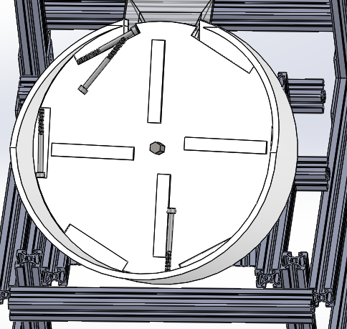To get the geometry of each part, we used a part file provided from Mcmaster-Carr. This allowed us to drop in a close simulation of each part. It also provided information about how the bolts would contact each other, allowing us to check for to see if thread lock might become an issue later on. Each simulation used a constant motor speed of 20 rpm. At the time we were still not certain of speed needed for each part, so 20 rpm was a good estimate at a universal speed.

We noted that the Solid Works calculator was straining to calculate the motion of parts in the machine. This was an issue due because 1 second of simulation at times took up to 1.5 hours to compute. We needed to turn down the number of times the integrator checked the math on the model. The contact accuracy was also lowered for faster calculation times. The worse problem with simulation calculation is when the computer would hit a singularity in the math model that would not be computed correctly. When this happened the calculation would immediately stop leaving only a partial simulation. If more simulation was needed, we would have to adjust the options 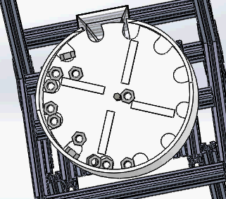and begin the long wait again. To help prevent this, 10 or less fasteners were used in simulations.

The simulations compared to the actual part movement within the machine where generally correct. Most of the part movement fit the overall movement of parts in the bowl. The way that the disks picked up the fastener and the way that the fasteners were agitated was fairly accurate. For early stage analysis, simulations were valuable to prove that the method of the machine could work.

The difference between the simulations and the actual machine came in the detailed part movement and scenarios. A computer will only be able to calculate a few given scenarios and conditions. In the real machine, thousands of part orientation and contact points exist. The downside that we had with simulating is that the computer did not want to compute large quantities of parts being simulated in the machine. When more parts are in the machine, part behavior may change. We also found jamming conditions and slot issues while testing the actual machine that the simulation did not pick up. This just shows that a computer can get close but is not a substitute for live tests.

**Part FEAs**

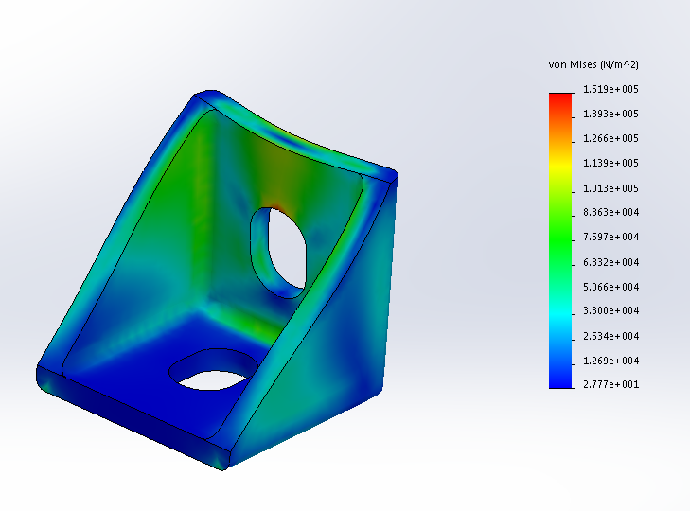 In order to analyze the forces on parts of our machine, we performed a few finite element analysis for parts that we believed would see the most stress. The we knew the majority of the frame being made from 80/20 extruded aluminum and having a tensile strength of 36,000 psi lead us to feel safe about our material selection for the frame. We also made L-brackets and T-Brackets from plate aluminum with the same tensile strength. Our ABS plastic was had a yield strength of 246ksi at minimum. The most important number to recognize for us was that our printed parts act as composites. The glue layer between the composite was the weakest factor with a shear strength of 4500 psi if we put the part into a Isolated stress loading condition where the direct stress is applied 90 degrees from the direction of the layers. For the following components we were not worried about this being an issue due to the parts having a large enough surface area to dissipate the weight of 50 M10 socket head screws, the heaviest part.

The 90 bracket was a part we were concerned when coming up with the concept of our design. We would use at least 1 bracket to connect beams together and ultimately hold key components of the frame, bowl, and user interface into place. These brackets had to be small and able to be applied at multiple angles. The first FEA performed was to prove that under a unit stress the design concept for our bracket would stand up to the weight of other components and the fasteners under fully loaded conditions. As seen in the figure __ the maximum stress from applying a 1 newton force to the bracket resulted in as stress of 151.9kpa or 22.03 psi. Form this we also got a deflection of .06299 mm. We did some prototyping and testing. During the test the part held 20 pounds without breaking, but extreme deflection was observed. We then ran an FEA at 20lbs and found that at 2x the weight of the machine, the part will experience 5.6mm of strain and be taking on 2053.7 psi. By having this number still under the half the needed stress to pull the bonding apart and be at 2x the machine 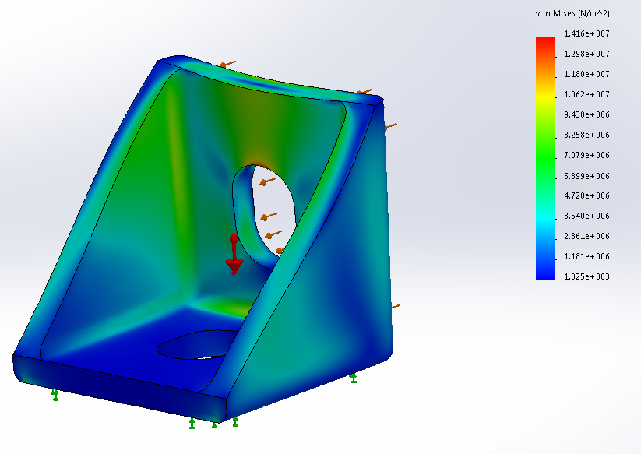weight proved that the bracket could be small, lightweight and strong. To make this FEA, gravity was applied, then the base was fix and the load was applied to the second part interface.

The second FEA was to prove that the motor shaft would be able to handle the amount of shear stress being applied from the interactions between 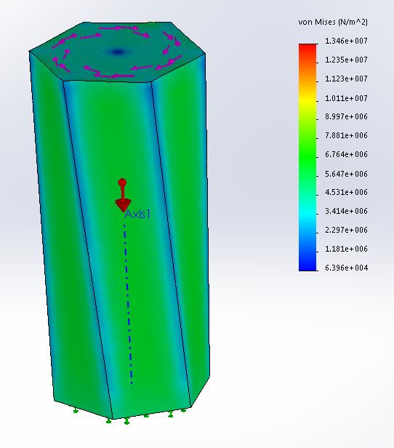the motor and the weighted plate. In order to get an idea of how the shaft would react, an FEA was created to test the unit resistance of 1Nm on the shaft face. In Figure __ we can see how the torque was applied to the shaft piece. By fixing one end and twisting the other, we could get an idea of how the shaft would react if the disk was twisting from the end. This was the most extreme condition for the shaft location. The stress experienced was less than the stress experienced was high but not out of the range of the ABS material. The shaft was created vertically, so the applied stress in this case acts as an isolated strain condition. This condition allows us to use the strength of the ABS material in our calculation. W still took the adhesive shear strength to be our deciding factor for the part due to it having the lowest strength of 4500 psi.

From the results of this FEA, it is observed that the stress on the shaft is 1.346 x 10^7 Pa or 1952.2 psi. This is almost half of the shear strength of the adhesive, and the load is 1Nm. The largest theoretical load would occur if all of the largest fasteners where applied at 1 point on the edge of the disk. The force that the shaft would see is 1489.6 Nm. This would be a problem if the entire load was a point load, applied directly at the edge of the disk and there if there was no 45 degree angle. What helped our FEA result even more was the fact that the torque was not being applied at the end of the shaft making deflection much less and the structure much stiffer. This restored confidence in our shaft design. We did not consider wear effects though and would eventually apply aluminum to 3 shaft faces to strengthen the shaft surface enough to handle the 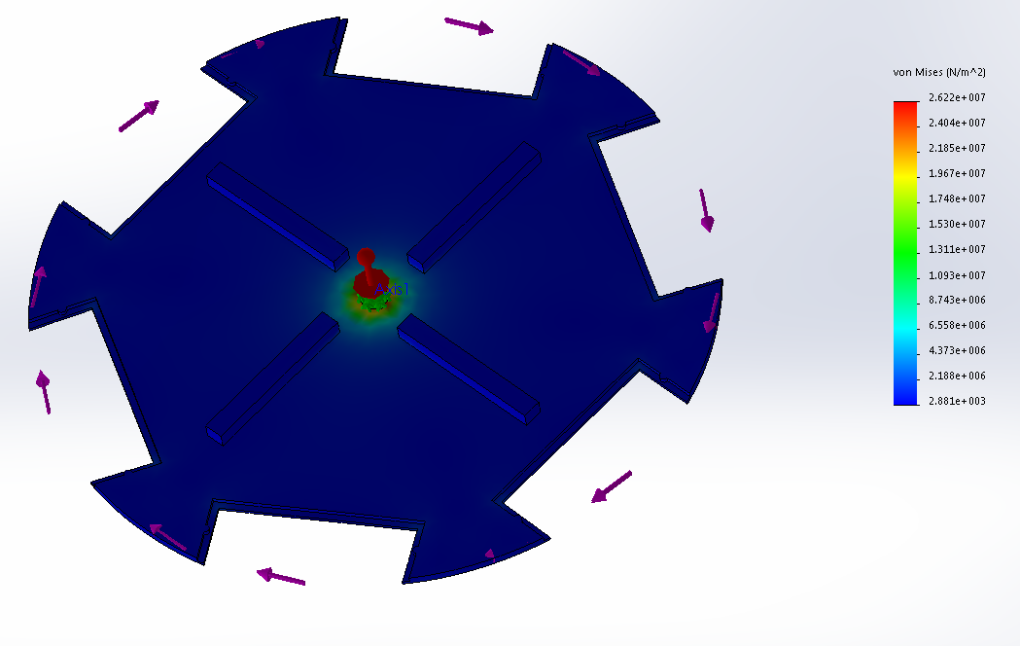torque.

The above FEA is of one of the master disk that were where intending to use early on. The FEA is disturbing, however the disks when applied did not act in this manor. This matches similar results that we found with our unit FEA on the shaft. Our stress around the shaft interface is 2.622 X 10^7 pa or 3802.9 psi. This is due to the low thickness around the shaft head and the full load being applied directly to the plate without any angle. By keying out more material with our later disk design, we turned the shaft into more of a gear design. This created more area for the torque to be applied over. Also after testing for some time, we found that the damaging effects on the material where less severe than what we had first thought.

These where the materials that we felt needed an FEA due to the forces applied to them. Once we increased the strength of our motor shaft with aluminum strips, the area of contact became greater and reduced the stress for the larger parts. The rest of the structure was made with durability in mind and created out of aluminum or thicker material, making the other components less likely to deform or fail.

**Testing:**

Since most of the mechanical designs are printed by 3D printer, it is important to perfect each part before printing. Though the test, the glued bowl is strong enough to hold fifty parts. It did not tend to separate apart. The size of the disk could just fit into the bowl, and the gap between the bowl and the disk is small. In this case, the parts could not stuck. The agitators on the disk could stirred the part in a high efficiency. The gap of the disk could only allow one parts getting into, and it just as same as what we assumed. Moreover, after cleaning up the extra printed material of the funnel, the size of the hole is

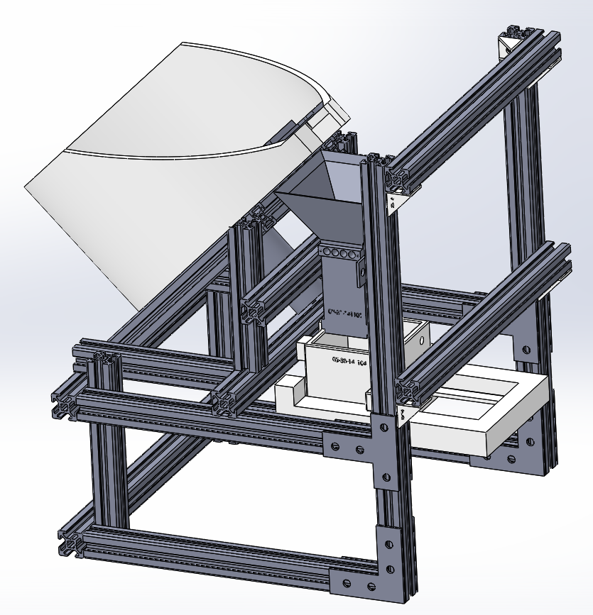**Final Assembly:**



Figure 1. Built Machine Figure 2. Finalized CAD Model of Machine Concept

Our finalized machine design is shown above in figure 1 and 2. As shown above, about fifty unorganized parts will be dropped into the bowl. The motor that is fixed on the frame will rotate a wheel inside the bowl. Depends on the types of the parts, different wheel and different inserts of the bowl will be utilized. The unorganized parts will be rotated into the gaps of the wheel, and sent to the top of the bowl. Then they will drop into the funnel through a big gap on the top of the bowl. There will be eight pairs of IR sensors, which attached on the side of the funnel, waiting for detecting the number and speed of the parts. After controlling the speed and the number of the parts, the rotating process will stop, and the correct number of parts will drop into the presentation bin. The waiting hand can easily push the slider that underneath the presentation bin, and receive the parts when the machine is ready.

The size of the total design including both mechanical and the electronical stuff is $270mm×300mm×350mm$. Because we fixed everything together on the stable frame by proper size of screws and nuts, the whole machine is easy to carry and move.

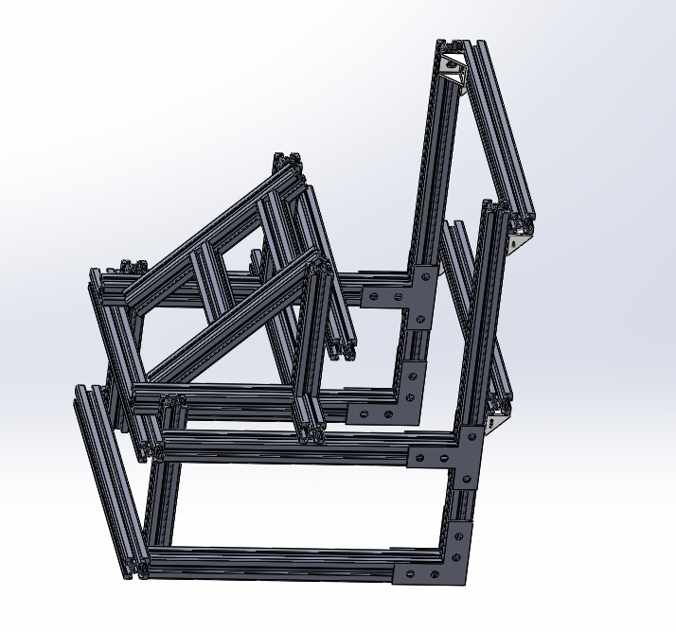

Figure 3. The Supporting Frame for the Total Design

The figure above shows the frame design of our machine. After the roughly drawing the outline of each component, we thought about the method to connect each component. It will be more delicate and easily to use if we can figure out a proper way to hold the whole machine. According to the mechanical and electrical components, we utilize the 8020 Aluminum alloy. It is bought from…. We cut it into different size, and put them together by utilize the proper fastener. Each component is fix one frame by using the nuts and screw. If there is any part that needs to be changed, we can easily change the position, length and angle between the beams, and mount the screw at the proper place that we want.

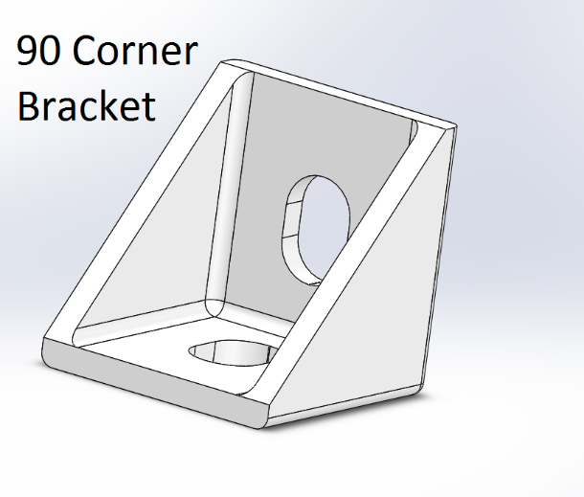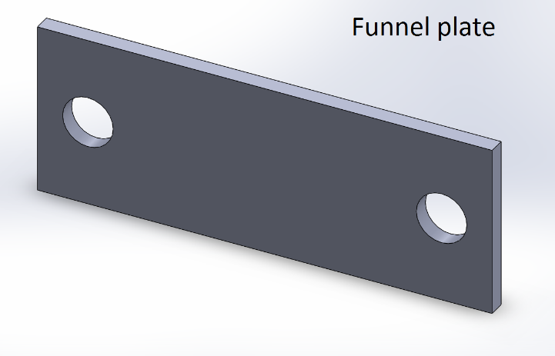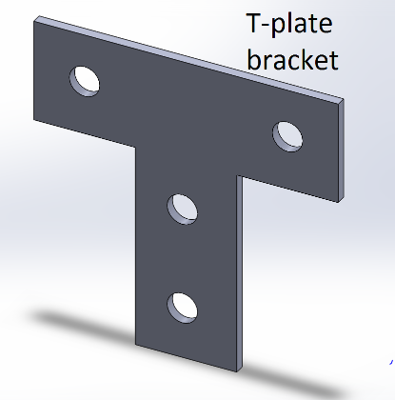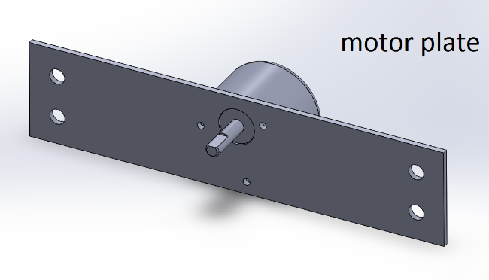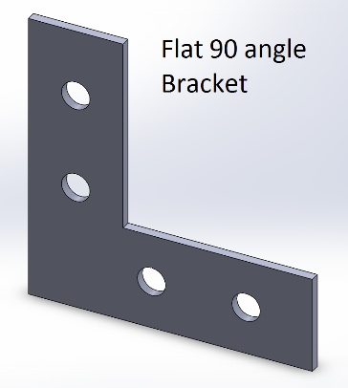

Figure 4. The Brackets and plates

The Brackets and plates in figure 4 are used to fix the fames and components. Except for fixing the motor, the diameter of the bolt that we utilized is 5mm. The bolt for the motor is 1mm depends on the size of the hole of the motor itself. The 90 corner bracket is printed by 3D printer, and we utilize about forty of them to fasten the frames. Thus, the frame is stable and hard to move when we using and testing the machine in the working process. The other Brackets and plates are built in steel in the machine shop. The diameter of the holes are 6mm, and we smoothed the edge of the brackets and the plates in case of hurting by the sharp places. Moreover, because the brackets and the plats is easy to change and move by bolts and nuts, the convenience of this design is obvious. For example, we can adjust the position of the motor plate in order to fasten the motor right in the center of the bowl.

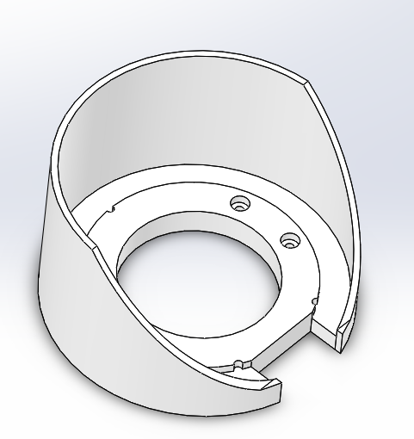

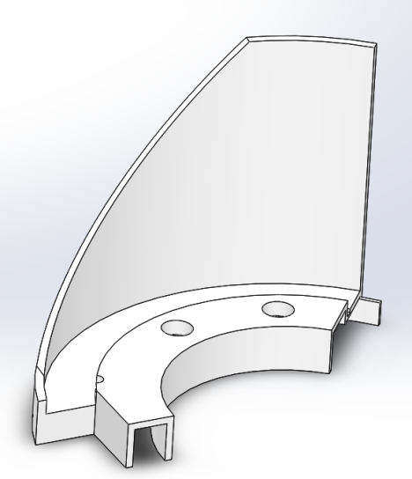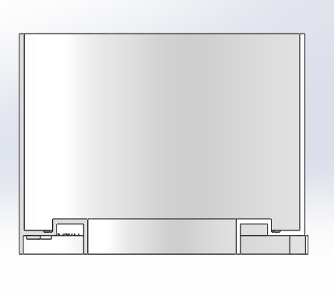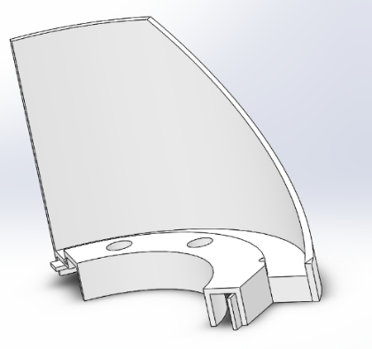

Figure 3. The Bowl and the Three Divided Parts of the Bowl That Used for Printing.

The figure shown above is the bowl. It is held up on the frame with an angel of 45 degree. The bowl is utilized to hold the bowl inserts, wheels and all the unorganized parts. Also, there is a cuboid gap on the side of the bowl, and the size is big enough for carrying all six types of parts. It allows the parts dropping into the funnel. The internal diameter of the bowl is 202cm, and the thickness of the wall is 4mm. For saving the cost of the bowl, we cut off a lot of material from the bottom. Because the bowl was not in a regular shape, we decided to use 3D printer. The size of the bowl was larger than the capability of the printer, so we printed it by dividing it into three parts. Then the left, center, and right part of the bowl were glued together. The glued bowl was firm during the test, and never tried to break apart.

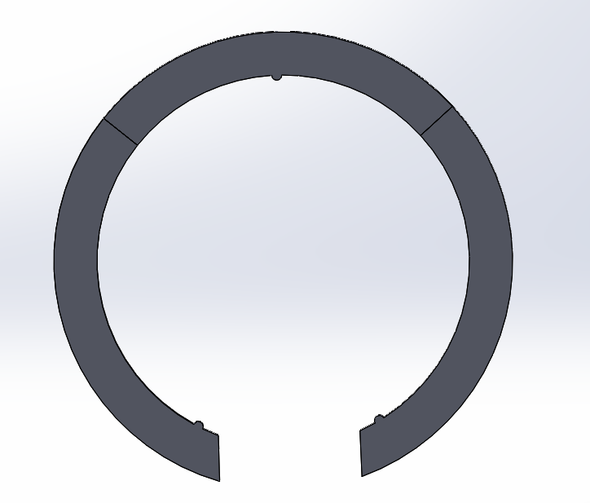

Figure 4. The Inserts of the Bowl

As shown above, the shape of the bowl inserts is same as the shape of the gap inside the bowl. The three small semi-circle are used to fix the position of the inserts. In this case, the rings will not move randomly inside the boal gap. Because the thickness of six parts are different, we have designed four different thicknesses of the rings including 6mm, 4.5mm, and . Then the thickness of the gap can be changed by easily putting the rings in. The size of the ring is larger than the capability size of the printer. Since we used 3D printer to print ABS material inserts, we divided each one into three part.

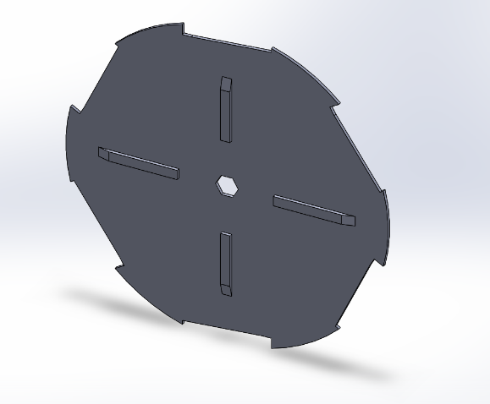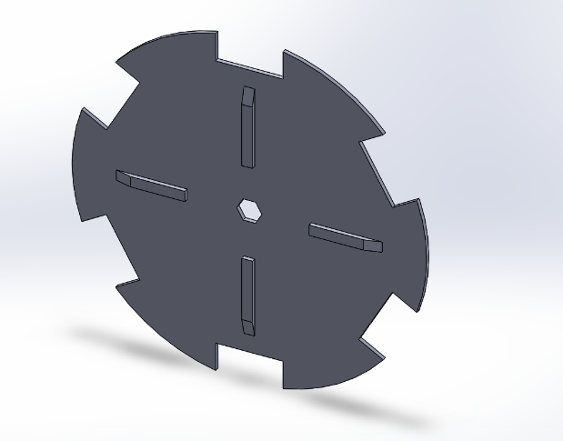

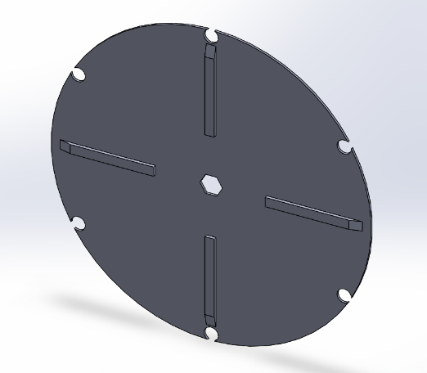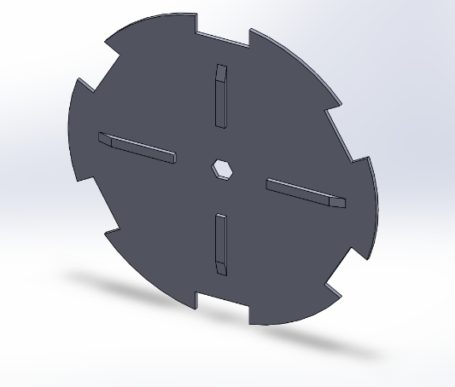

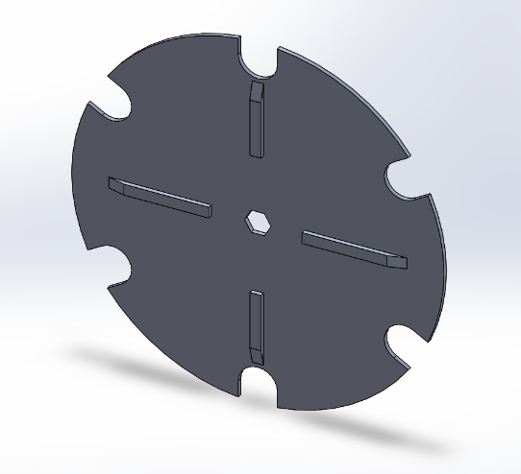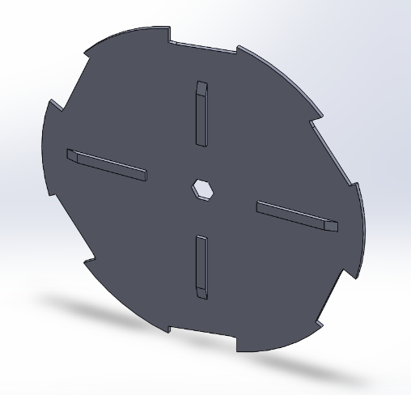

Figure 5. Six types of wheels

The figure shown above is the wheels for each parts. As we know, there are six kind of parts that might be sorted. The inserts of the bowl can used to change the thickness of the gap, and the wheels can change the outline shape of the parts. Because we don’t need to care about the thickness when designing the wheel, the thickness of the wheels are 2mm. Thus, we save a lot of material by printing the thin wheels. There are four agitators on each of the wheels. It is used to stir the parts. Because there are about fifty parts that need to be organized, it is important to make them apart, and they can easily drop into the gaps. All the six wheels are printed by 3D printer. Also, the shaft will be attached to the middle of the wheel in order to send the power for rotation process.

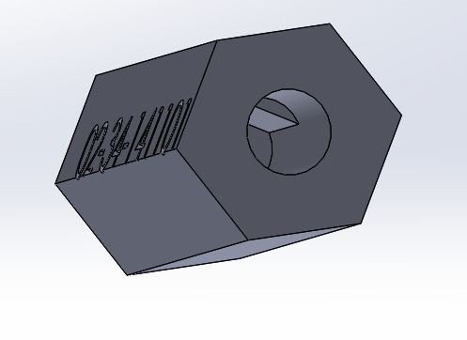

Figure 6. The shaft

The shaft is used to connect the motor and the wheel. Since the hole of the shaft is designed according to the size of the motor, the motor can easily attached to the hole of the shaft. Then, we super glued the shaft and motor, and the shaft will be more stable. The external shape of the shaft can just fit into the wheel. In this way, the wheel can rotate in the same rotational speed while the motor rotating, and the motor can easily control the rotating process of the wheels. The shaft is built by 3D printing.

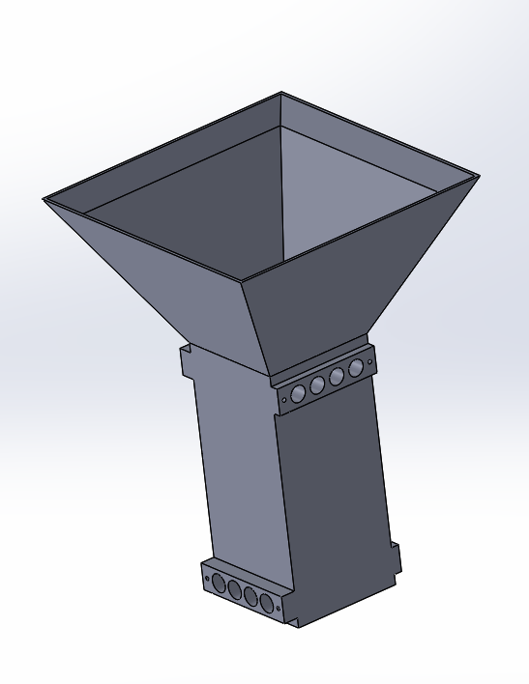

Figure 7. Funnel

The funnel with IR sensors is an important part to counting the number of the parts. As shown above, the upper part of the funnel is right below the gap of the bowl, and the size of the entrance is enough for all the parts to drop in. Then the parts will be detected by the sensors. Eight pairs of sensors are attached to the hole of the funnel in two level. Once the part is detected, the electronic screen will add the number, and the motor will receive the feedback of the speed. In this case, the motor can better control the speed of machine. In order to cut accurate size of the sensor hole, we printed funnel by 3D printer.

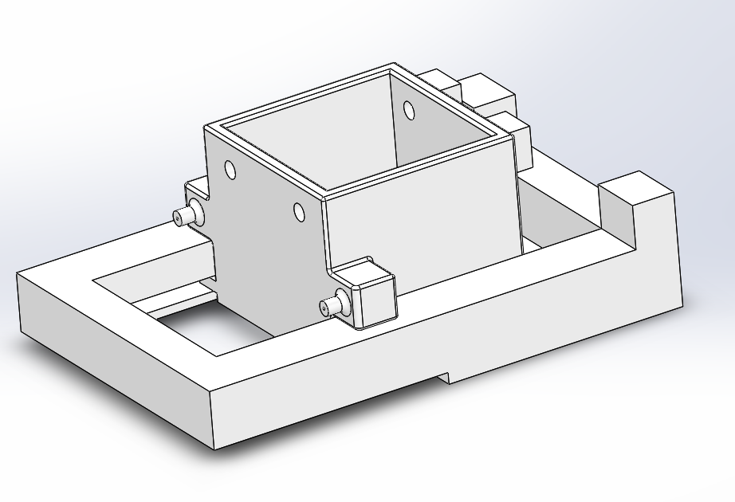

Figure 8. Presentation bin and push slider

As shown above, the parts will drop into the presentation bin after going through the funnel. When the machine is ready, the machine will stop rotating, and the correct number of parts will be stored in the presentation bin. Then, the awaiting hand can easily push the slider underneath, and receive all the needed parts. Both presentation bin and push slider are made by 3D printer, and the material is ABS plastic. The presentation bin is fixed on the frame, and it holds the slider as while. In order to connect presentation bin and slider, and control the position of the push slider, there are two springs on the each side of the dispenser. In this way, the spring will extend when the push slider is pushed, and the spring can pull the slider back to the normal position when the force disappears.

To fasten together the frame of the assembly we used a veriety of screw and a set of Din 562 standard square nuts. The nuts were thin enough to fit into the channels of the 80/20 extruded alluminum on a flat edge. When turned with a screw, the nut corners would hit the channel and begin to tighten the joint. All of our frame fasteners worked with these nut.

The most common fastener we used in the design was a 6mm M5 button head cap screw. This screw was just long enough that we put 3.5 mm between the mounting surfaces of the nut and screw head. This fastener was picked because it would not bottom out in the 80/20 channels. The team used these fasteners for all structural frame construction. These screws held together the 90 degree brackets and the other plate brackets to make the frame joints. They also hold the motor plate and the power supply plate to the frame.

Any other fasteners that we applied on the major mechanical componenets of the machine were picked because they were able to reach the bottom of the 80/20 extrude channel and still have the head of the screw compressing the mounting surface of the part being mounted. Each of these screws where an M5 socket head cap screw with a 0.8 thread pitch to match the Din 562 standard square frame nut. All fasteners made for part attachment to the frame had a threaded shaft diameter of 5mm to fit in the channel of the 80/20 extrude.

**Please Check The Discussion, If it seems irrelevent, then remove it**

**Discussion:**

Our final design solution is greatly different from our original design. The original design was made with only functionality in mined and did not take into effect cost, assembly, and control of part size on certain components. The original presented design was made crudely to allow for the original ideas to take shape and preform initial testing based off theory or software.

As we analyzed the idea of price and making parts fit together. It was found that making parts that used thin ABS printed parts where cheaper than our original parts. We became more comfortable with working with ABS after we tested the prototyped design for a 90 corner bracket. The idea for this design was altered from working aluminum brackets for sale on the web at Mcmaster-Carr.com or 80/20.com. The brackets used gussets to strengthen the joint. Some used multiple screw locations to stiffen the joint and increase contact area. Since our machine weight is 10 pounds, we felt that with multiple applications of a smaller light weight bracket could be used to have high strength with minimal space. We also removed tabs that fit into slotted sections of the 80/20. This allowed us to use our bracket for a wider range of applications including parts on an angle, which the shelf bought brackets would not be able to do.

In order to ensure that this application would work, we tested the bracket design. A small sample of 10 90 corner brackets was printed in order to test the bracket design strength. In order to get an idea on how the bracket might perform, we used FEA from Solid works. By comparing an FEA with 1N applied to a mounting face and the other mounting face fixed, we could predict the deflection of the part under loading. This could be compared to the test results in order to estimate how the brackets will perform.



To conduct the experiment, four brackets where secured to a 2x4 using Philips head sheet metal screws. The brackets where up and down in orientation and attached to the edge of the 2x4. The 2x4 was then clamped to a table using a C-clamp to prevent it from moving off the table. By two hooks and string, weight was applied to each of the brackets. The weights had known measurement labels. This test did not need to be very precise, due to the predicted weight that one bracket was to lift was approximately 5lbs. The test was stopped at 22lbs because the part was deformed, there was no need to go higher when only 5lbs was a comfortable working weight of the machine and the design has multiple double brackets applied at the joints.

ME Appendix

**Drawings**

Bowl

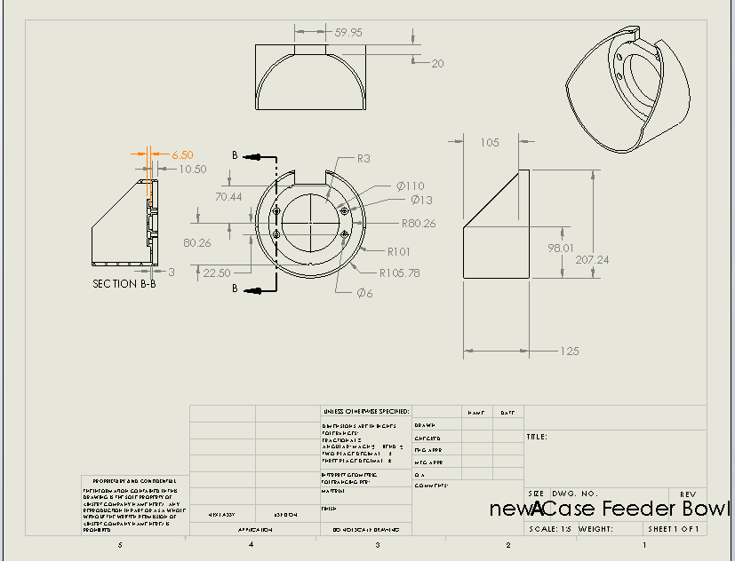

Presentation Bin

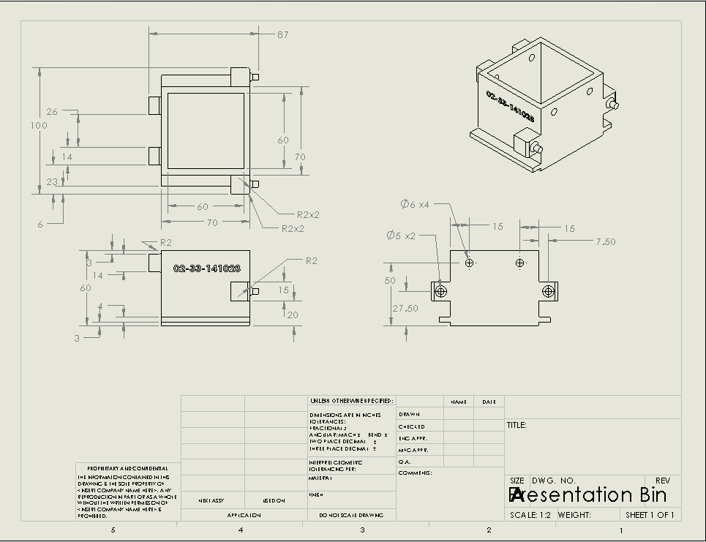

Slider

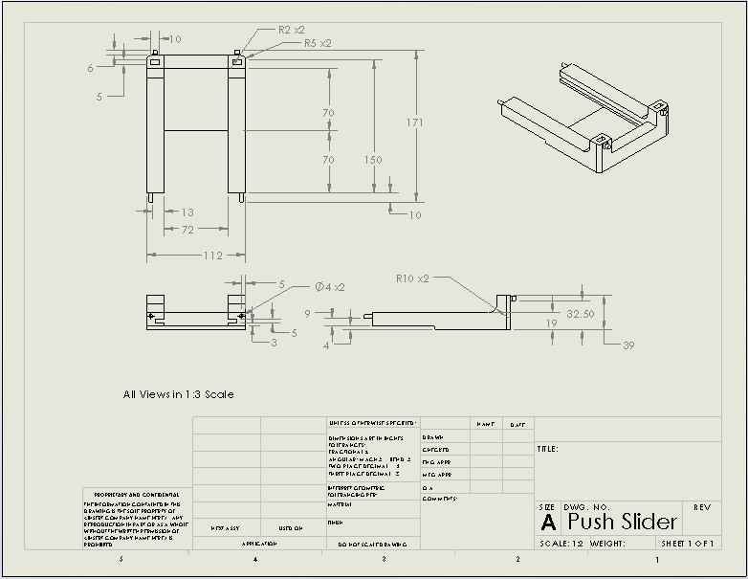

Slider End

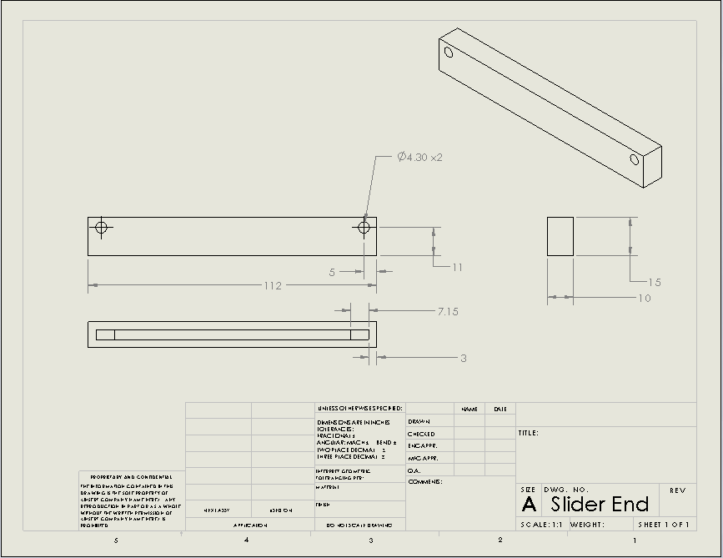

Motor Plate

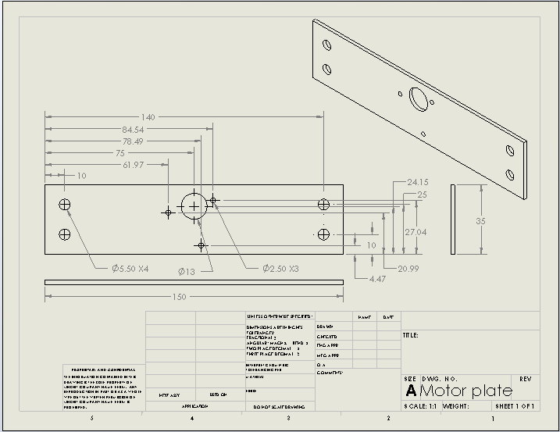

Funnel Mounting Plate

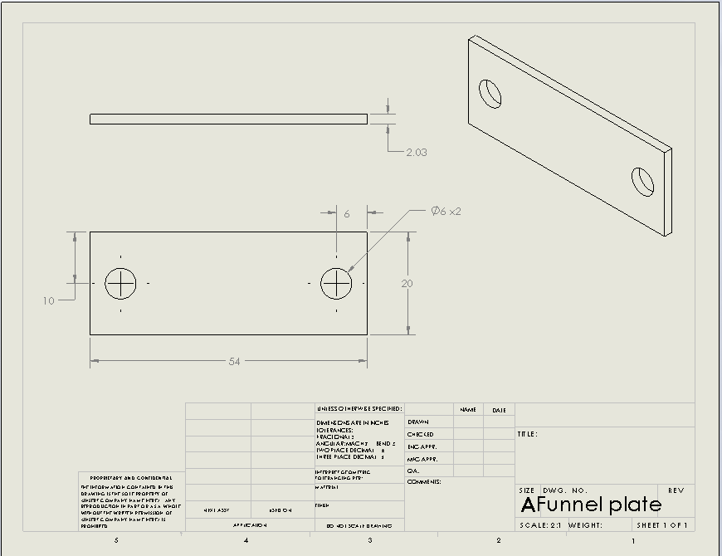

T- Bracket Joint Plate

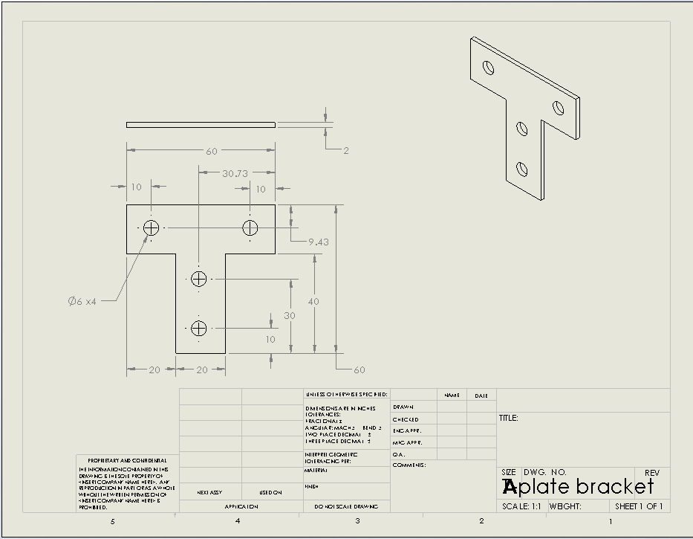

L-Bracket Joint Plate

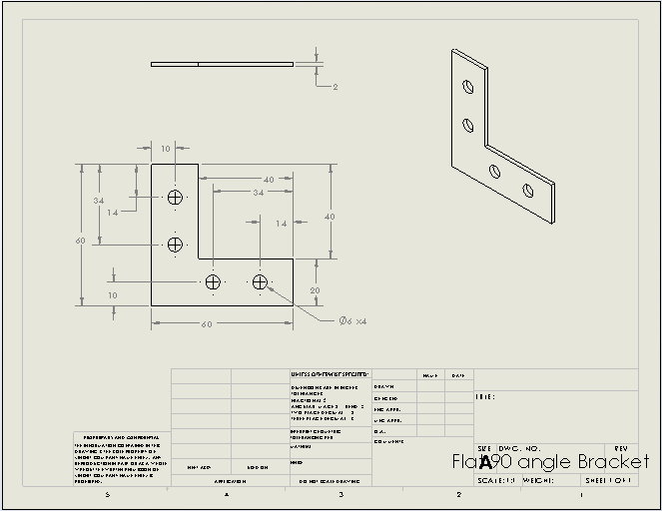

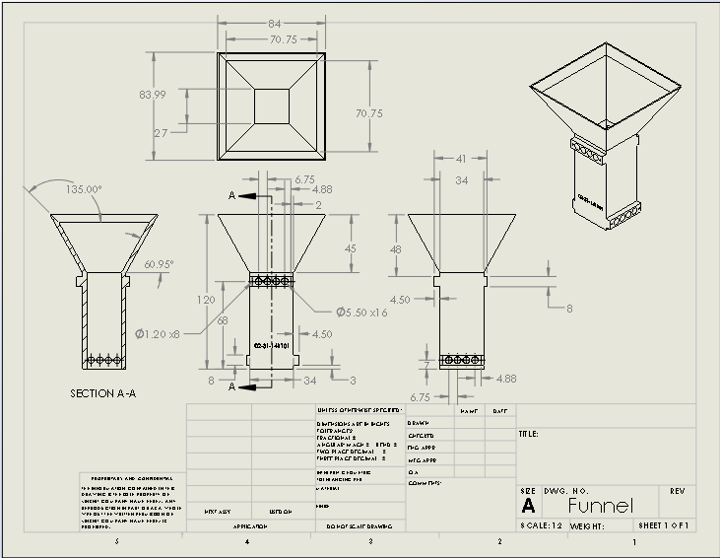Funnel

90 Degree Angle Bracket

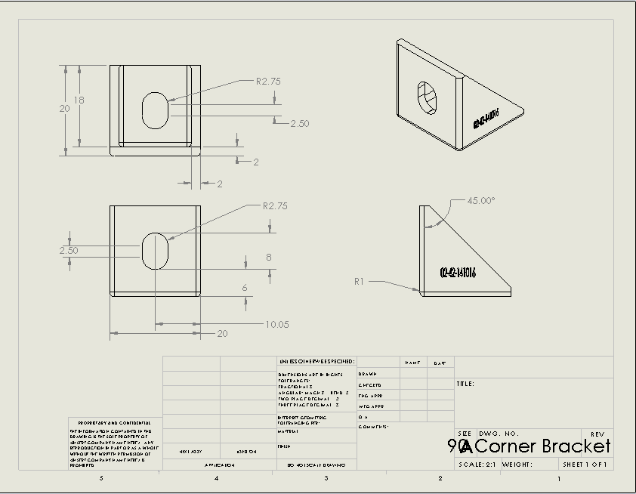

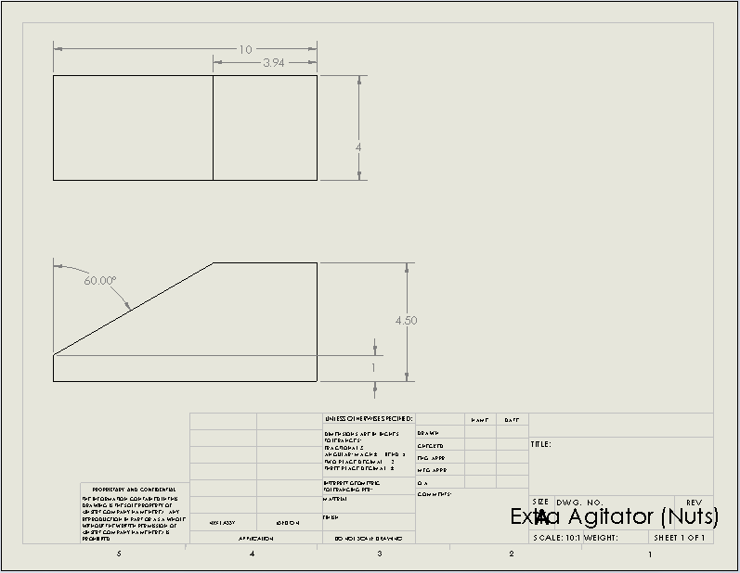Extra Plate Agitator

80/20 Extrude

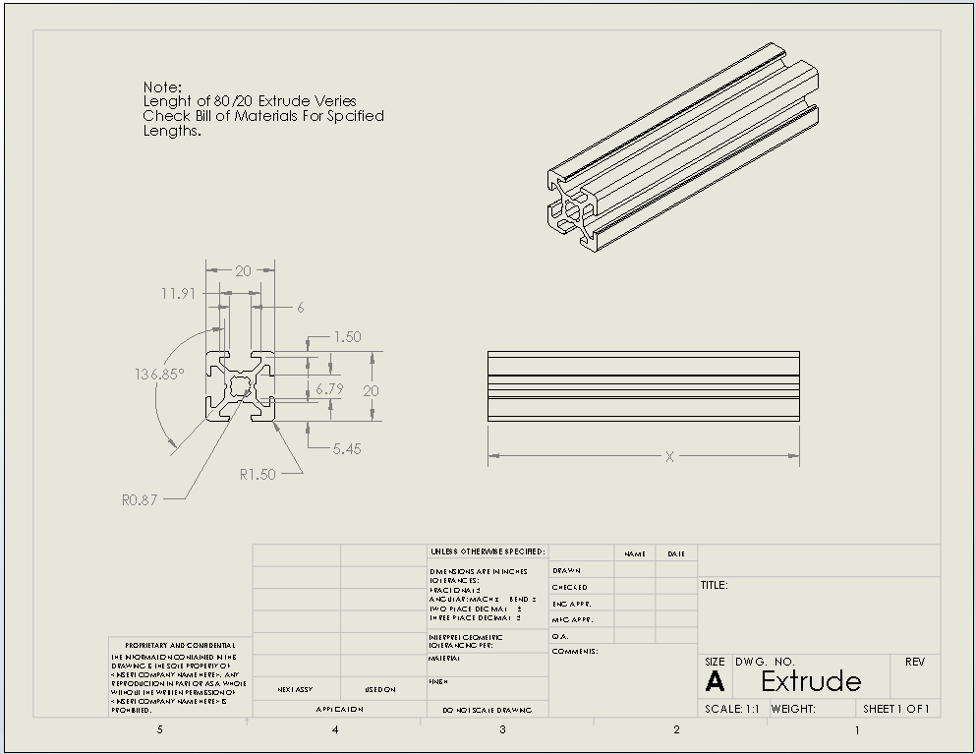

**Competition Fasteners Raw Stats**

References

<https://www.youtube.com/watch?v=JfCTuXfHzrY>

<https://www.youtube.com/watch?v=9pWtjwkrPCs>

<http://www.firstcadlibrary.com/pages/extrusion.asp>

<http://www.youtube.com/watch?v=JH-7d9IuVqY>

<http://www.youtube.com/watch?v=QgxFMs6k-Hs>

[tp://www.youtube.com/watch?v=edlPr0UNVYY](http://www.youtube.com/watch?v=edlPr0UNVYY)

<http://www.youtube.com/watch?v=BBqOjUgIN2g>

[**http://www.unit-conversion.info/pressure.html**](http://www.unit-conversion.info/pressure.html)

<http://www.youtube.com/watch?v=rd6DqjREv-w>

<http://www.secs.oakland.edu/~latcha/me492/3Dprinting.html>

<http://www.secs.oakland.edu/~latcha/me492/syllabus.html>

<http://www.secs.oakland.edu/~latcha/me492/proj_f14.html>

<http://almetal.nl/techinfo/nut/nd562.htm>

[**http://www.mcmaster.com/#**](http://www.mcmaster.com/#)

[**http://www.grainger.com/category/aluminum-extrusions/structural-framing-systems/material-handling/ecatalog/N-c3qZ1z0qh5v**](http://www.grainger.com/category/aluminum-extrusions/structural-framing-systems/material-handling/ecatalog/N-c3qZ1z0qh5v)

[**http://www.8020.net/**](http://www.8020.net/)

**http://www.solidworks.com/**

S.Kalpakjian, S. Schmid, “Manufacturing Processes for Engineering Materials Fifth Edition” Prentice Hall, Inc. 2008 Pgs 15-18, 58-66, & 141